In this task, I have done the lead lag relationship analysis and I got a relationship coefficient of 0.7823295378983014 and I found that BTC was leading ETH by 22 days.

In the lead-lag strategy I have used that whenever BTC had positive daily returns 22 days ago we buy ETH today and if they were negative then we will ETH today.

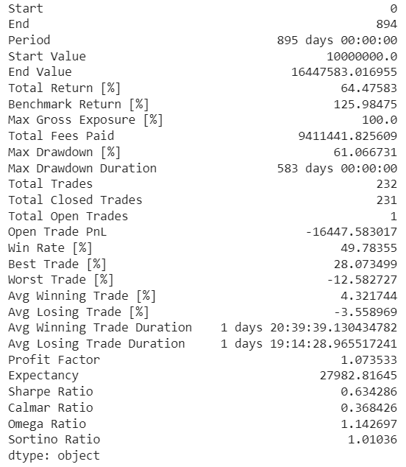

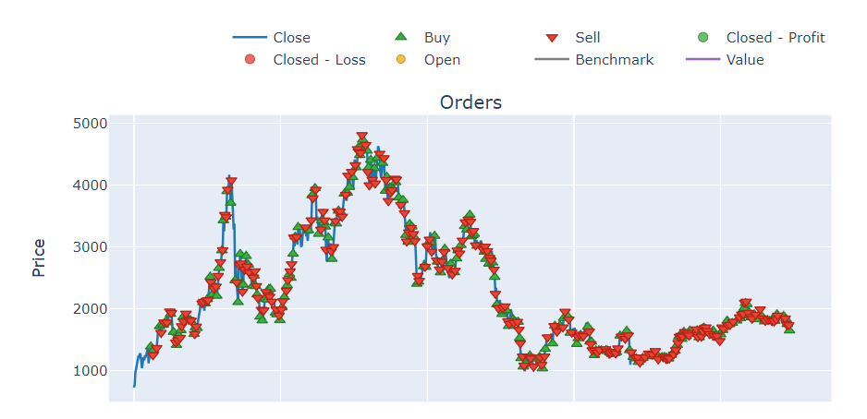

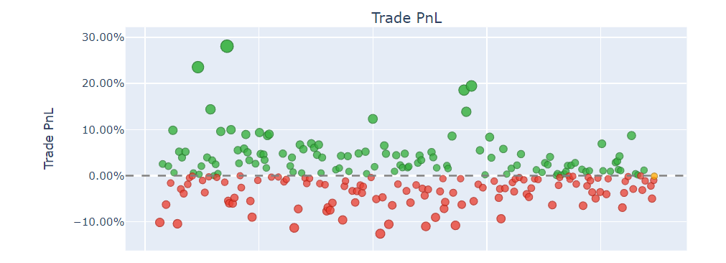

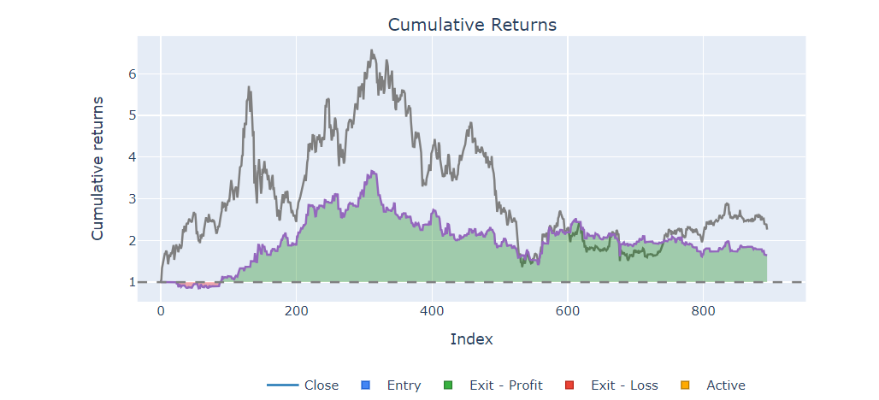

In the individual ETH trading, I have used MACD line as strategy. Whenever MACD crosses the signal line from below it we buy ETH and whenever MACD crosses the signal line from above, we sell ETH.

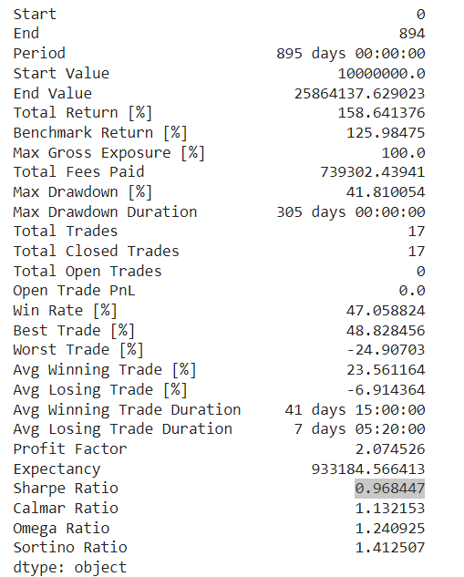

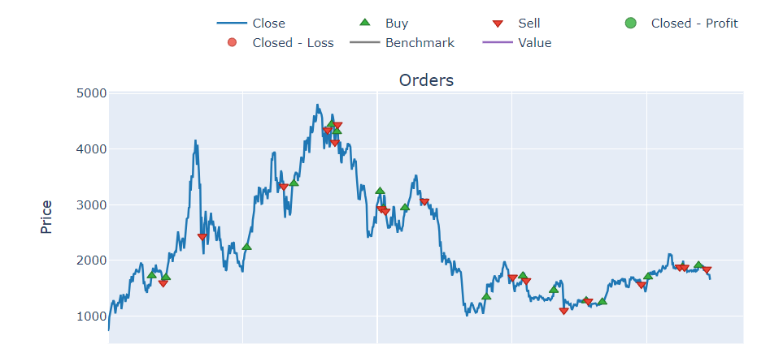

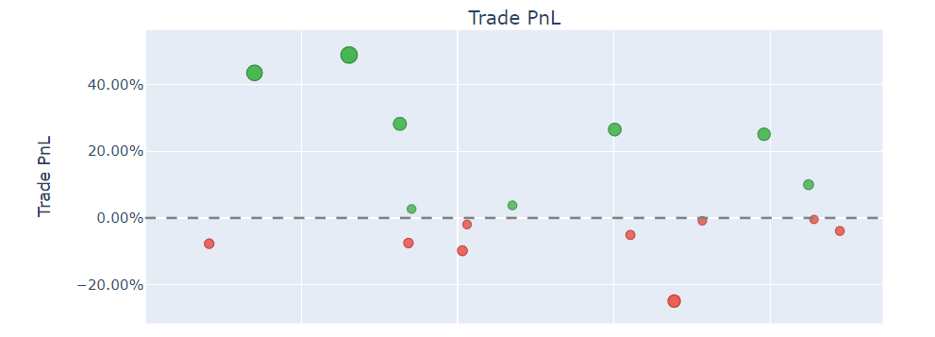

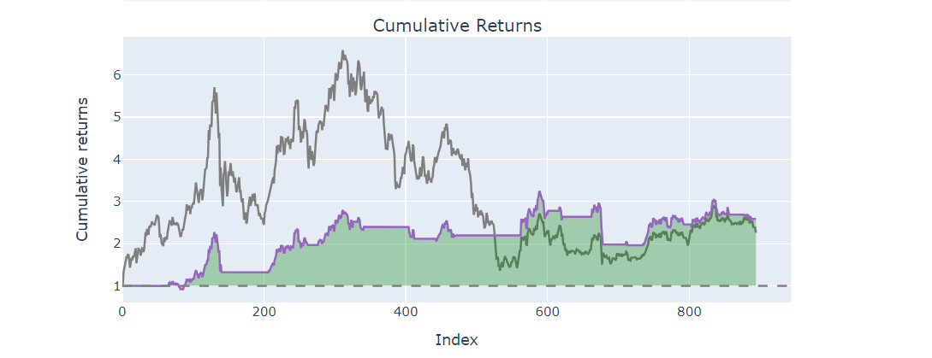

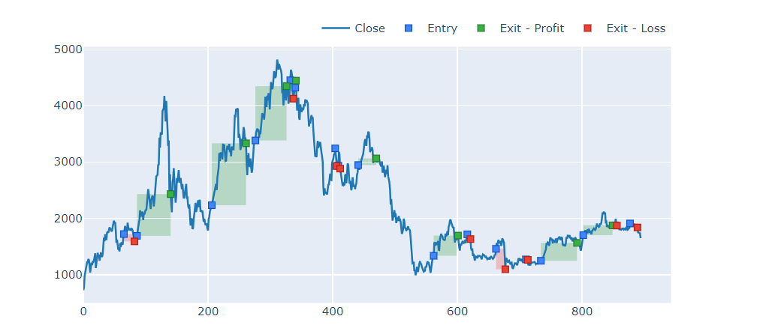

We have used vectorbt here for backtesting.

